**Farewell to Laima Čekelienė, National Member for Lithuania**

04/07/2019

Eurojust sadly bids farewell to the National Member for Lithuania, **Ms Laima Čekelienė**, who, after 11 years at Eurojust, is returning to Lithuania to finish her prosecutorial career, dealing with matters of international cooperation in the Office of the Prosecutor General in Vilnius.

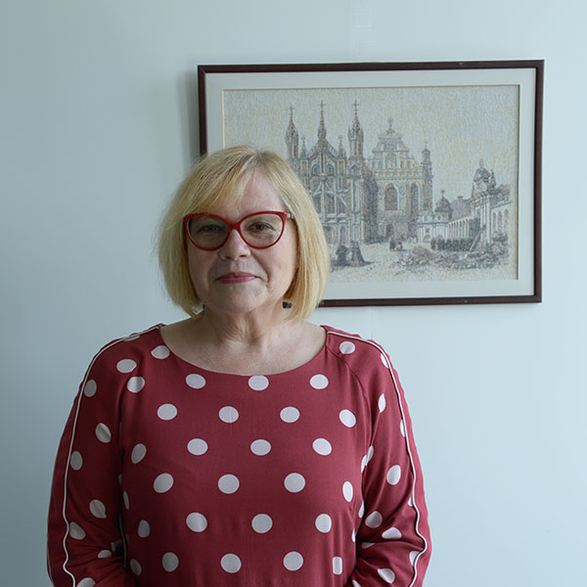During her time at Eurojust, she vowed to change the thinking of Lithuanian prosecutors, making them more flexible in accepting the assistance of Eurojust in matters of international cooperation. Her colleagues in Lithuania could never have succeeded in closing cases without the support of Eurojust, in general, and the National Desk of Lithuania, in particular.

After receiving a Diploma of Master of Laws from Vilnius University in 1979, she began her distinguished judicial career as an Investigator in the Ministry of the Interior of the Republic of Lithuania. She also served a Professor of Administrative Law at the Police Academy of the Republic of Lithuania from 1990 to 1992.

She became a Prosecutor in 1994 in the State Prosecution Unit of the Vilnius District Prosecutor’s Office, and was promoted to Deputy Chief Prosecutor of the Crimes Against a Person’s Life and Health Unit. In 1998, Ms Čekelienė became Chief Prosecutor in the International Legal Cooperation Unit. Before joining Eurojust in 2008, Ms Čekelienė served for 10 years in the Department of Criminal Prosecution of the Office of the Prosecutor General in Vilnius. She also served as Lithuanian contact point for the European Judicial Network.

While at Eurojust, Ms Čekelienė was a member of three College teams: the Board for External Relations with Partners, the EJN & Liaison Magistrates Team and the Judicial Cooperation Instruments Team.

On the occasion of her departure, Ms Čekelienė said:  *‘I am fully committed to the concept of Eurojust and its added value for national prosecutors. Even seemingly small cases can have big consequences if Eurojust is involved. Most important are the relationships you build with your colleagues. We are a big family here, and assistance is gladly provided in an atmosphere of trust and respect. Therefore, I go back to Lithuania with mixed emotions. I especially want to thank my assistant, Aliona Apanas. Without her, I would hardly have achieved the results praised by the Lithuanian Prosecutor General and the Lithuanian General Police Commissioner.*

*Eurojust has won a strong and honourable place among other European agencies; still young, but already self-confident, aware of its value and its goals. Now the results of our work speak for themselves. The time has come for the outside world to properly assess what Eurojust is doing, as well as to realise the great added value that our countries receive. I believe that the golden age of Eurojust is still to come.’*